Rakel María Brynjólfsdóttir rmb3@hi.is
Dæmahópur 9 skil: 02.10.15
Dæmatímakennari: Kristófer Montazeri

Tölvunarfræði 1
Heimadæmi 2

Dæmi 1

public static double[] hlutSlembiFylki(int n) {
int N = 2*n;
double[] a = new double[N];

for (int i = 2; i < N ; i = i+2 ) {
a[i] = i/2;
}

for (int i = 1; i < N ; i = i+2 ) {
a[i]= Math.random();

}

return a;
}

Dæmi 2

public static double geomean(double[] a) {

double n = a.length;
double margfeldi = a[0];
for (int i = 1; i < n; i++) {
margfeldi = margfeldi*a[i];
}

double svar = Math.pow(margfeldi,1/n);
return svar;
}

Dæmi 3

public class SlembiTeikna {

public static int slembi739(int r) {

int t = ((171*r)+7) % 739;

return t;
}

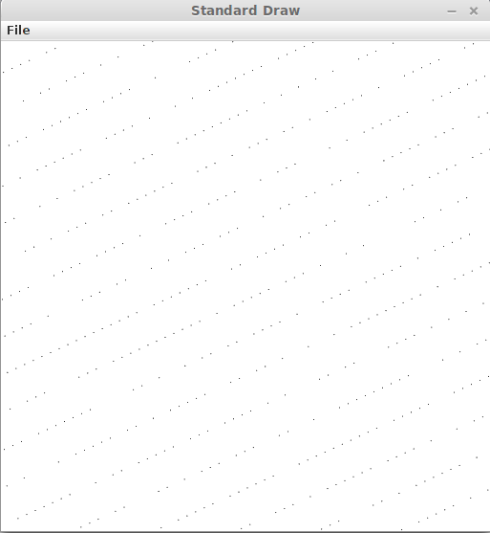
public static void main(String[] args) {

int[] a = new int[1000];
int r = 0;

for (int i = 0; i < a.length; i++) {
a[i] = slembi739(r);
r = a[i];
}

double[] b = new double[a.length];
for (int i = 0; i < a.length ; i++ ) {
b[i]=a[i]/738.0;
System.out.println(b[i]);
}

for (int i = 0; i < a.length; i++) {
StdDraw.point(b[i/2],b[(i/2)+1]);
}
}
}

Dæmi 4
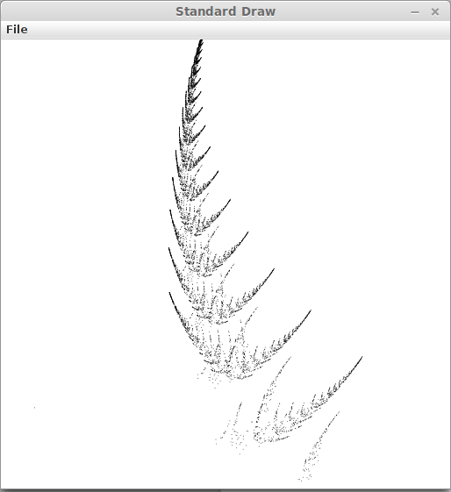
4
0.01 0.85 0.07 0.07

4 3
0.10 0.10 0.600
0.75 0.04 0.075
0.10 -0.16 0.500
-0.15 0.28 0.575

4 3
0.00 0.16 0.000
-0.04 0.85 0.180
0.33 0.22 0.045
0.26 0.24 -0.086

Dæmi 5

public class TeningaGamble {

public static int diceToss() {
int dice1 = (int) (Math.random()*6+1);
int dice2 = (int) (Math.random()*6+1);
int sum = dice1 + dice2;
return sum;
}

public static boolean firstToss() {
int sum = diceToss();
if (sum == 7 || sum == 11) return true;
else if (sum == 2 || sum == 3 || sum == 12) return false;
else return nextToss();
}

public static boolean nextToss() {
int sum = diceToss();
if (sum == 7) return false;
else if (sum == 2 || sum == 3 || sum == 11 || sum == 12) return nextToss();
else return true;
}

public static void main(String[] args) {

int T = Integer.parseInt(args[0]);
int wins = 0;

for (int i = 0; i < T; i++) {
firstToss();
if (firstToss() == true) wins++;
}

System.out.println("Number of wins: " + wins);
} }

rakel@rakel-Satellite-L655 ~/Documents/SKÓLI/Tölvunarfræði 1/Forrit $ java TeningaGamble 1000
Number of wins: 754

